Name: Siem Khattyavatey (p20250056)
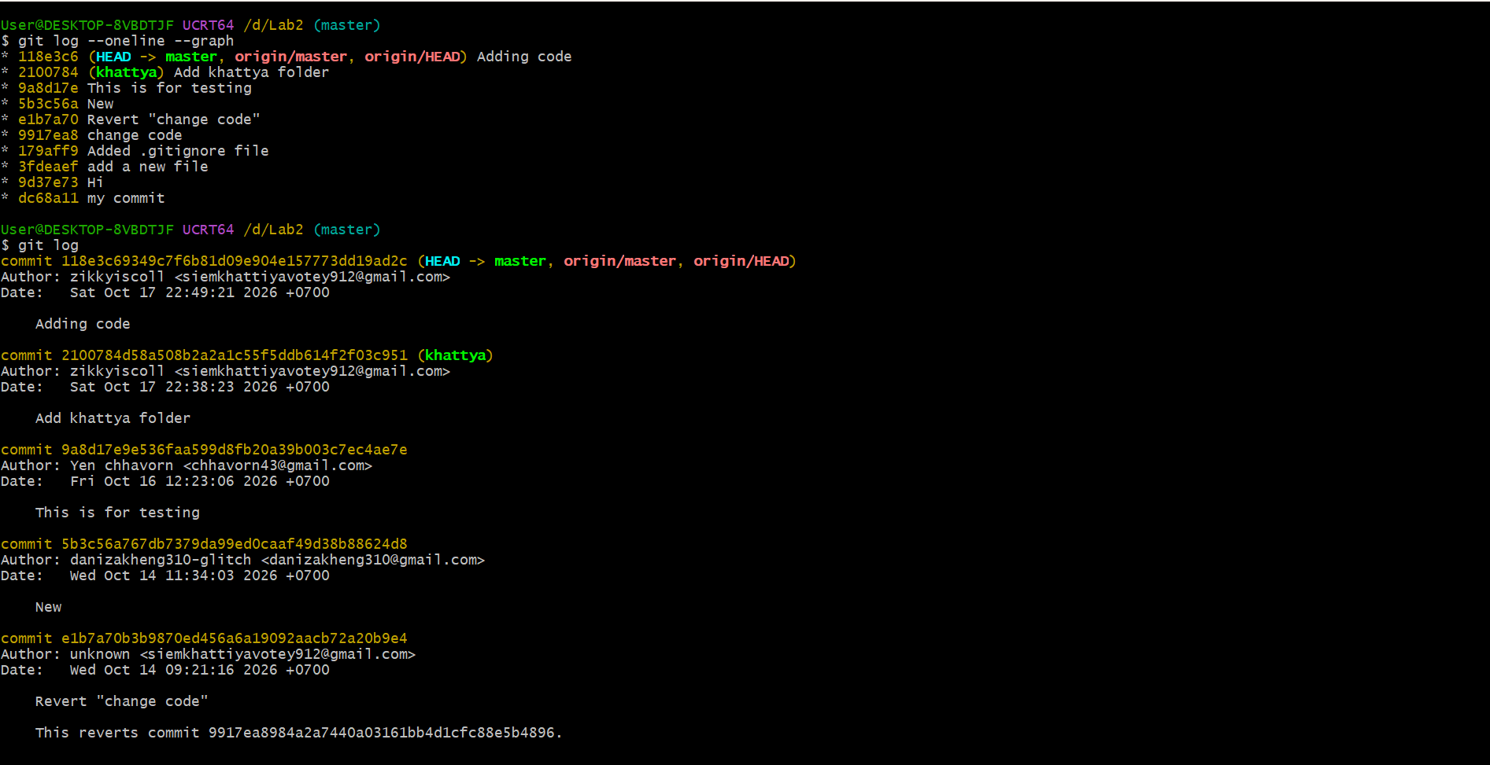

Group: 3 (AEICS)

